Sumdog- linking an adult’s account to your child’s school account
Log in with your parent account.

In the top of your dashboard, you will see a settings icon.
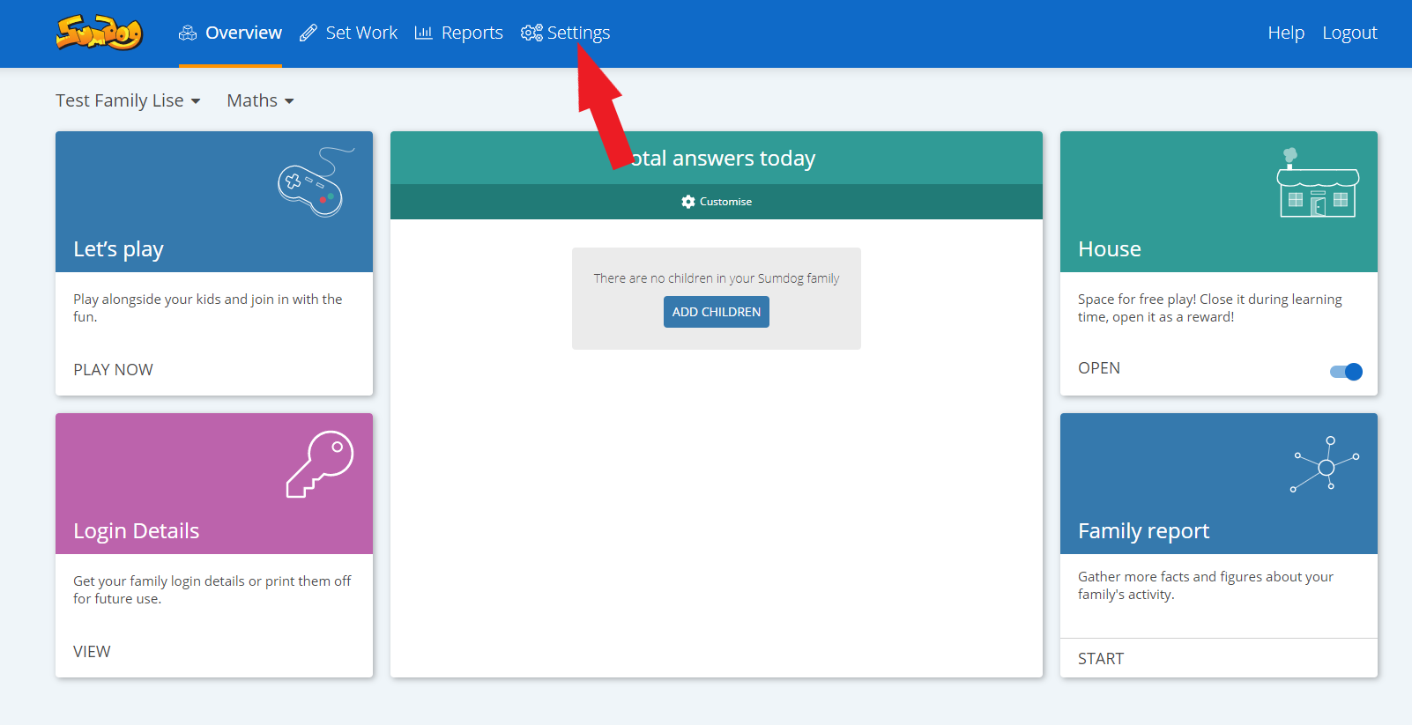
Click on this.
Then, click edit in the children box.
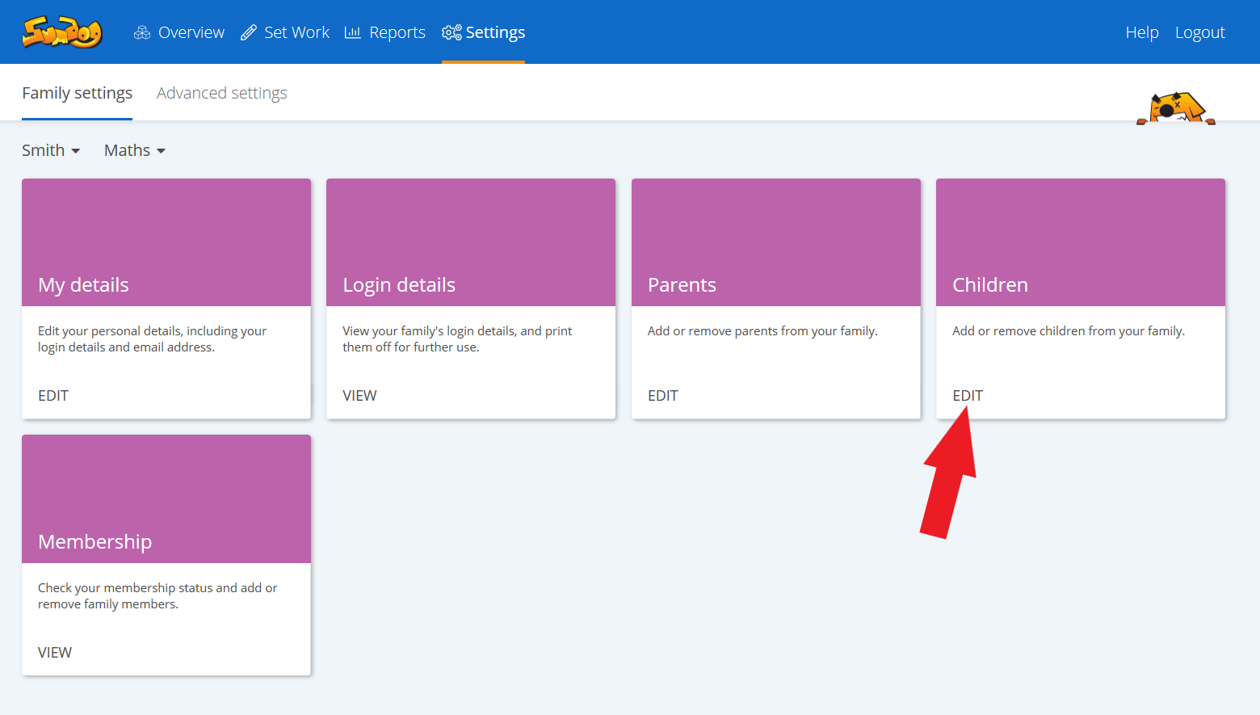
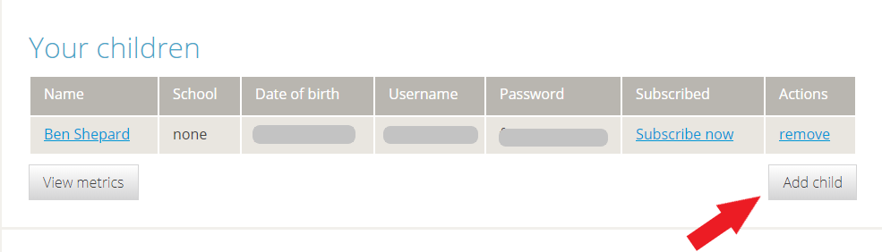
This will bring up a list of children linked to your account. Click on add child.
Click on my child has a Sumdog login from school.
Then type in the login details given by your child’s teacher.
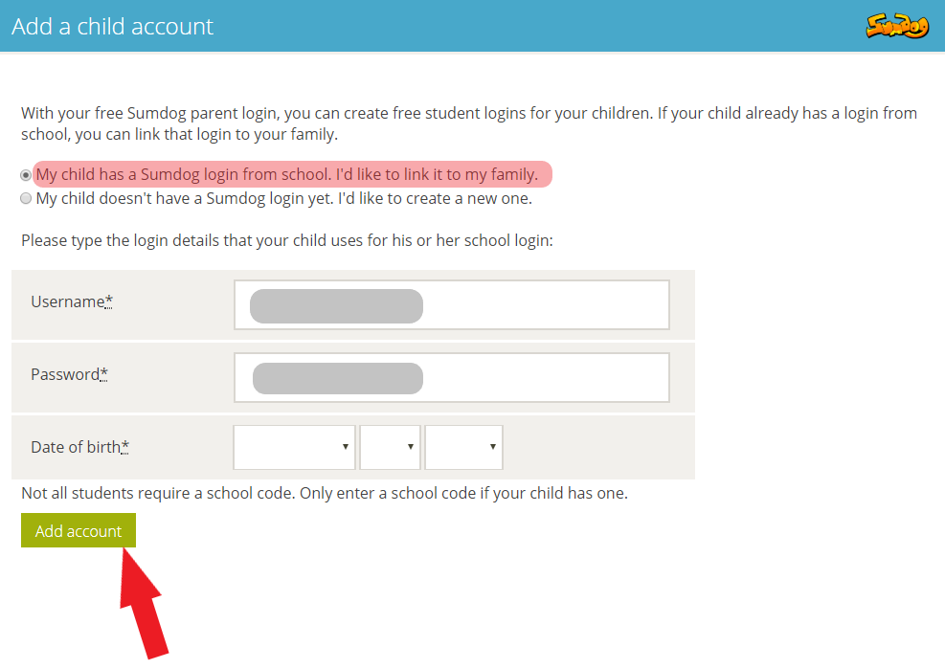
Click on the green box ‘add account’.
You will then be linked through to the Children page. You will see your child’s name, with their username and password.
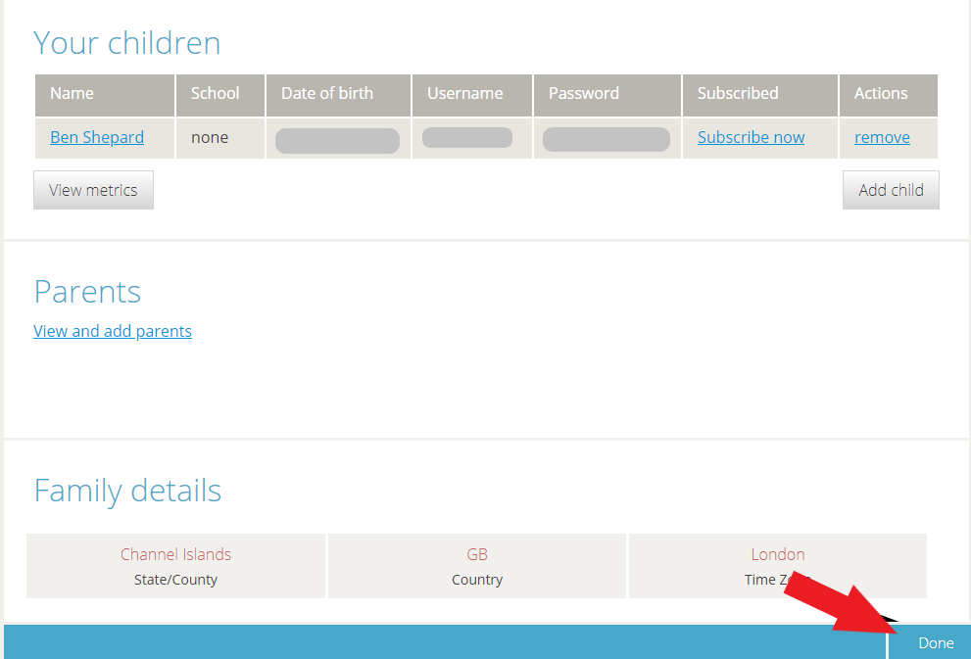
Click done when you have finished.

